Android Development and Web Services

CA2 – MoviesWebServices Android Application Report

Object Oriented Programming Design  
15th March 2017  
  
Submitted by:  
Sylwia Calka N00146095

Contents

Introduction 3

Functionality 3

Movie Class 3

XML Parser 4

JSON Parser 6

Class diagram 7

# Introduction

The MoviesWebServices application was developed as a part of the CA2 for Object Oriented Programming Module. This is an Android application developed using Android Studio. This application accesses a Web Service. On the Web Service the XML and JSON files are stored. Those files can be downloaded using Androids HttpURLConnection and parsed into a list view.

The application contains:

1. Movie class that reflects the web service data
2. Uses XML parser to pull the content
3. Displays a list with the content
4. Uses images in the list
5. Uses fragments
6. Uses JSON parser

# Functionality

The MoviesWebServices application allows to pull the data from a Web Server in an XML or JSON format. This data is parsed into a movie list array and then the content of the list is displayed to the user. To start the HTTP-task the user needs to open the menu in the upper right corner of the application and choose between pulling XML or JSON file. When the button is clicked the Async Task runs in the background and pulls the data from the server. At the completion of the task in onPostExecute method the display is updated and the user sees the list of movies.

# Movie Class

Movie class is a model of the movie object. It consists of getters and setters for elements of the movie object. Each movie has a title, directors, rating, year, genre, photo and a bitmap. Below is an image of the Movie class.

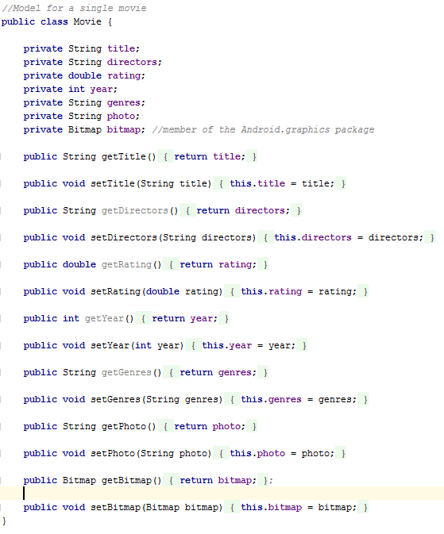

Image Movie class

# XML Parser

Extensible Markup Language (XML) is a text format widely used for storing content on the internet. To display the content of XML file to the user it needs to be parsed first. The XmlPullParser is an Android’s interface that determines parsing functionality. The content of XML file is passed to the MovieXmlParser and then processed. The parser generates events for starting tag, ending tag and for text events. The parser goes through each event and checks what tag is it currently on. If it is on the start tag, it creates new Movie object. Then it goes through each tag and assigns values to the Movie object. When it reaches the end event the parser moves to another tag. Below the image 2 shows the xml elements and its attributes. The image 3 shows the screenshot of MovieXMLParser.

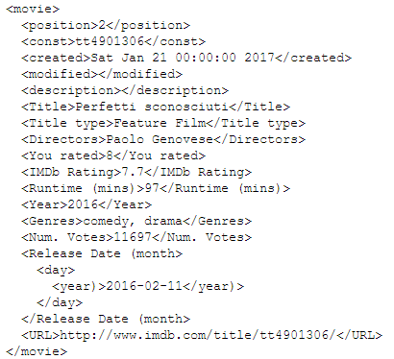

Image Part of XML file

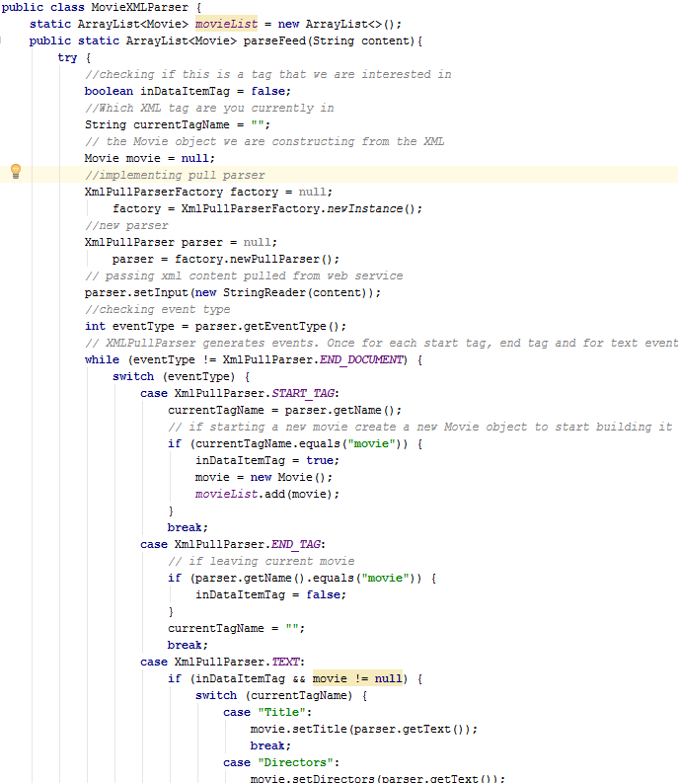

Image XML parser

# JSON Parser

JSON stands for JavaScript Object Notation. It is a data format consisting of attribute-value pairs. It is used for delivering content to the users from the server. To parse the data the parser is used. The MovieJSONParser creates a new JSONarray in which the pulled JSON content is passed. The parsing function goes through each element in the array, creates a new Movie object for each element and sets the content based on keys and values in the JSON file.

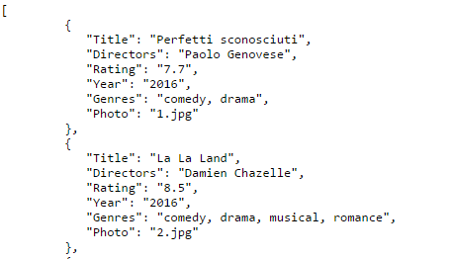

Image Part of JSON file

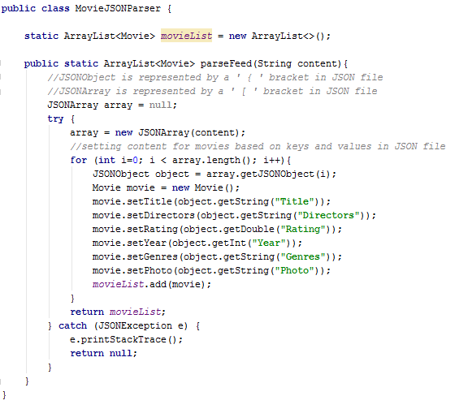

Image JSON parser

# Class diagram

The class diagram describes the structure of the MoviesWebServices application. This application is designed using the Model-View-Controller design pattern. The model is responsible for managing the content and the logic of the application. The View is an output and visualization of the data. The Controller interprets the actions and communicates with both Model and View.

…

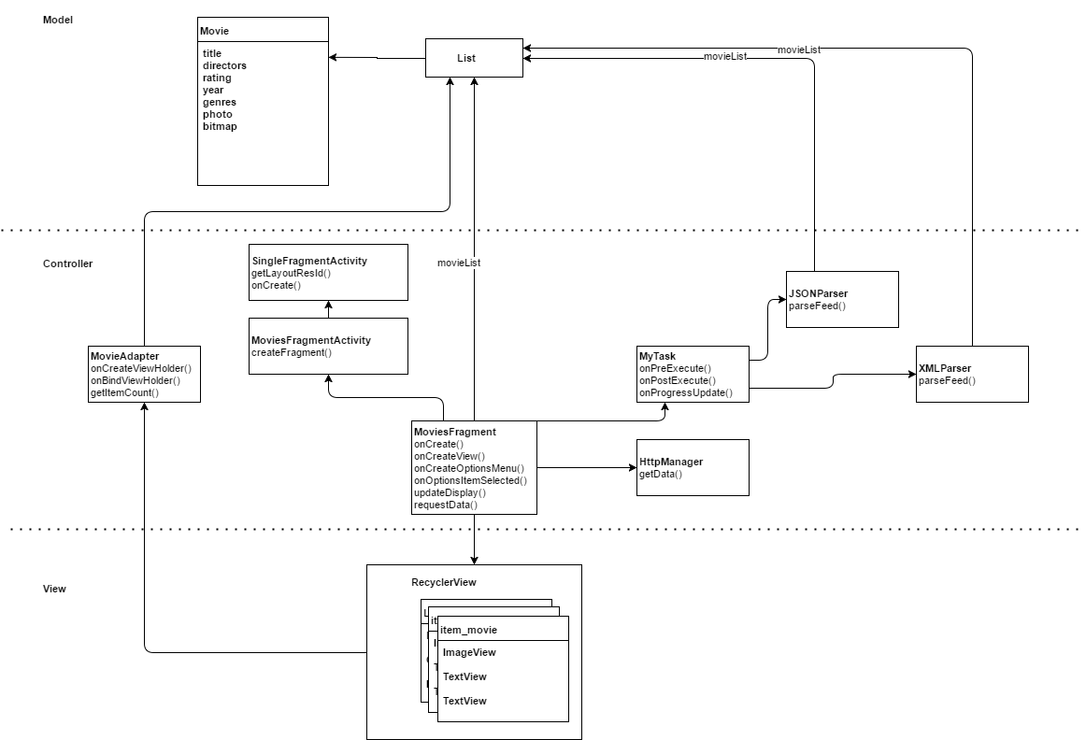

Image 6 Class model